Exp 6.1 Finite Word length Effects
Program:
clc; clear; close all; %% Signal fs = 1000; f = 50; t = 0:1/fs:0.1; x = sin(2*pi*f*t);
%% Quantization Levels L = [8 16 32]; colors = {'r','g','m'}; figure; for i = 1:length(L) % Quantization xq{i} = round(((x + 1) * (L(i)-1) / 2)) * (2/(L(i)-1)) - 1;
% Error & MSE
e{i} = x - xq{i}; mse(i) = mean(e{i}.^2); % Plot Quantized Signals subplot(4,1,i+1); stairs(t, xq{i}, colors{i}, 'LineWidth', 1.2); title(['Quantized Signal (' num2str(L(i)) ' Levels)']); xlabel('Time (s)'); ylabel('Amplitude');
grid on;
end %% Original Signal subplot(4,1,1); plot(t, x, 'b', 'LineWidth', 1.5); title('Original Signal'); xlabel('Time (s)'); ylabel('Amplitude'); grid on;
%% Display MSE fprintf('MSE for 8 Levels = %f\n', mse(1)); fprintf('MSE for 16 Levels = %f\n', mse(2)); fprintf('MSE for 32 Levels = %f\n', mse(3));
%% Error Plots figure; for i = 1:3 subplot(3,1,i); plot(t, e{i}, 'LineWidth', 1.2); title(['Error (' num2str(L(i)) ' Levels)']); xlabel('Time (s)'); ylabel('Error'); grid on;
end
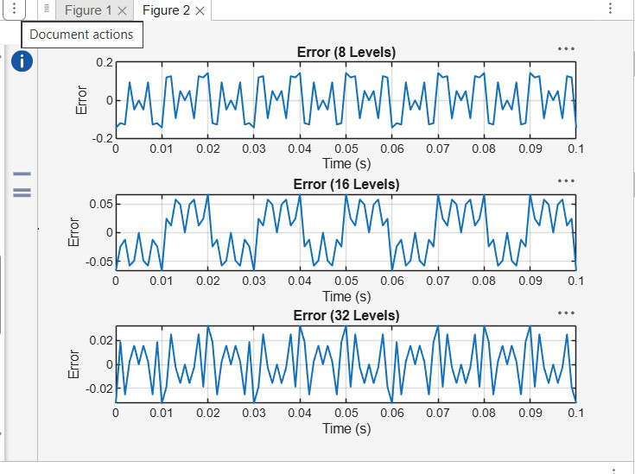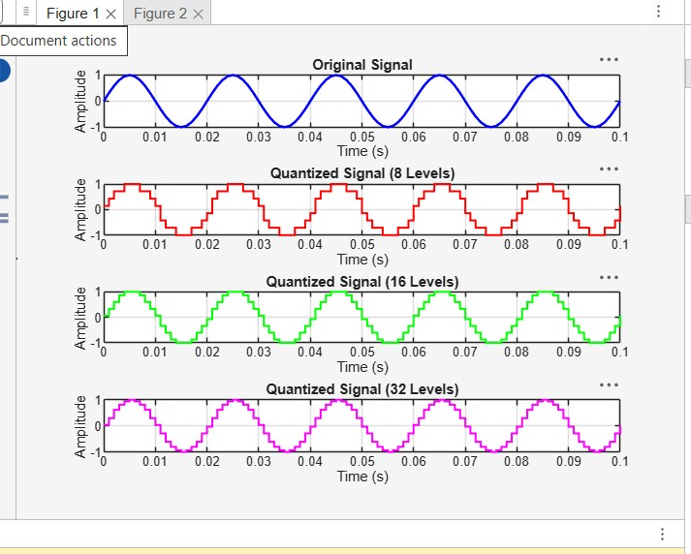
6.2 Analysis of Finite Word Length Effects in Digital Signal Representation Using
Program:
clc; clear; close all n=0:79; x=sin(2*pi*n/40); q=8; xt=floor(x*q)/q; xr=round(x*q)/q; et=x-xt; er=x-xr; % Fig 1 figure plot(n,x,'b',n,xr,'r','LineWidth',1.5) grid on title('Original vs Quantized') legend('Original','Quantized')
% Fig 2 figure plot(n,x,'b',n,xt,'r',n,xr,'g','LineWidth',1.5) grid on title('Truncation vs Rounding') legend('Original','Truncated','Rounded')
% Fig 3 figure stem(n,et,'r') hold on stem(n,er,'g') grid on title('Quantization Error') legend('Truncation','Rounding')
% Fig 4 figure bar([mean(et.^2) mean(er.^2)]) set(gca,'XTickLabel',{'Truncation','Rounding'}) grid on title('MSE Comparison') ylabel('MSE')
